TERNA ENGINEERING COLLEGE
Department of Computer Engineering
NIRMAN LAB
Facilitating Theme-Based Experiential Learning for Real-World Engineering Solutions
Academic Year 2026 - 2027
A NIRMAN LAB PROJECT REPORT ON

TITLE: MaatriRaksha

Submitted in partial fulfilment of the term work requirement of Semester III

Bachelor of Engineering in Computer Engineering

Second Year of Engineering. Division: C

Submitted by

Name of student | Sneha Dipak Sagale
Roll No. / PRN | TU3S2627007
Class, division and branch | COMP-SE-C-C2
Semester and academic year | 2026-27
Semester theme | “Arogya Pranali: Intelligent Health Systems for Bharat”
Project title | MaatriRaksha
Faculty mentor | Rohini Patil

Certificate

This is to certify that the project report entitled

TITLE: MaatriRaksha

is a bonafide work carried out by the following students of Semester III , Department of Computer Engineering, Terna Engineering College, under the Nirman Lab programme during the academic year
2026 – 2027, in partial fulfilment of the term work requirement.

Name of student | Roll No. / PRN
Sneha Dipak Sagale | TU3S2627007
__________________________ __________________________ __________________________
Faculty Mentor | Head of Department | Principal/Director IQAC

Date: 22/10/2026 Place: Nerul

Approval Sheet

This project report entitled
is approved for the term work and oral examination of Semester ____ in the Nirman Lab
programme.
Internal Examiner: ___________________________________ Signature: ____________________
External Examiner: ___________________________________ Signature: ____________________
Date: ____________________ Place: ____________________

Declaration

I / We declare that this written submission represents my / our own ideas and work in my / our own words. Where others’ ideas, words, data, images, code or tools (including AI tools) have been included, they have been properly cited and acknowledged. Photographs and interviews were taken with the consent of the people involved. I / We understand that any violation of the above will be the cause for disciplinary action.

Name of student | Roll No. / PRN | Signature

Date: ____________________

Acknowledgement

I would like to express my sincere gratitude to my project guide and the faculty members of Terna Engineering College for their valuable guidance, support, and encouragement throughout my NIRMAN Lab project.
I am thankful to the college for providing me with the opportunity to work on MaatriRaksha: “Recognize Early. Refer Early.” This project helped me understand how technology can be used to address real-world challenges in maternal healthcare, particularly the early identification of pregnancy danger signs and timely referral support.
I would also like to thank all the respondents who participated in my Google Form survey and shared their valuable opinions. Their responses helped me understand the problem better and identify the needs that my proposed solution aims to address.
Finally, I am grateful to everyone who directly or indirectly supported and motivated me throughout this project. This experience has enhanced my knowledge of web development, problem-solving, research, and the practical application of engineering concepts to community problems.

Abstract

The project MaatriRaksha is developed under the theme “Arogya Pranali: Intelligent Health Systems for Bharat” and aligns with Sustainable Development Goal 3 (Good Health and Well-being). It addresses challenges faced by pregnant women and frontline healthcare workers, particularly ASHA and ANM workers, in identifying pregnancy danger signs and arranging timely medical referrals. A Google Form survey was conducted to understand awareness of pregnancy emergencies, existing referral challenges, and the improvements people expect in maternal healthcare. The findings are intended to guide the design of a simpler and more accessible referral system. The final problem statement is that early warning signs of obstetric complications are frequently missed in high-burden states due to under-equipped frontline workers and the absence of structured, real-time referral pathways. Engineering knowledge in web development, database management, user-interface design, and system analysis is applied to develop the proposed website using HTML, Tailwind CSS, JavaScript, Node.js, and MongoDB Atlas. The prototype aims to provide a maternal assessment checklist, risk alerts, healthcare facility information, and referral tracking. Further usability testing and clinical validation are required to evaluate its effectiveness. The project aims to support earlier recognition, faster referrals, and better coordination in maternal healthcare.

Keywords: MaatriRaksha, Arogya Pranali, Maternal Healthcare, ASHA Workers, Emergency Referral, Intelligent Health Systems

Nirman Architecture Canvas

1. Theme | 2. SDG Mapping | 3. Community Problem
Arogya Pranali: Intelligent Health Systems for Bharat | SDG 3: Good Health and Well-being. SDG 10: Reduced Inequalities. | Early warning signs of obstetric complications are frequently missed in high-burden states due to under-equipped frontline workers and the absence of structured, real-time referral pathways.
4. Stakeholders | 5. Root Cause | 6. Subject Mapping
Pregnant women, ASHA workers, ANM workers, family members, primary healthcare centres, hospitals, obstetric healthcare professionals, and healthcare authorities. | Limited access to structured pregnancy assessment tools, insufficient resources for frontline workers, lack of awareness of danger signs, difficulty identifying suitable healthcare facilities, and the absence of organised referral tracking. | Web Development, Database Management Systems, Software Engineering, UI/UX Design, Information Processing, and System Analysis.
7. Engineering Concepts Used | 8. Alternative Solutions | 9. Selected Solution
Responsive web design, database management, form validation, risk-alert logic, healthcare facility search, referral tracking, information retrieval, and multilingual interface design. | Community awareness programmes, printed maternal health guides, healthcare helplines, frontline worker training, mobile health applications, and a digital maternal healthcare referral platform. | MaatriRaksha — “Recognize Early. Refer Early.” A proposed platform to support frontline healthcare workers in identifying pregnancy danger signs, finding healthcare facilities, and organising timely referrals.
10. Prototype | 11. Validation | 12. Impact
Web-based prototype featuring a maternal assessment checklist, risk alerts, healthcare facility information, referral tracking, and planned regional-language and offline-friendly support. | Google Form survey conducted to understand awareness of pregnancy danger signs and challenges in maternal healthcare referrals. Actual survey findings should be added from the collected responses. Further usability testing and clinical validation are required. | Potential to improve awareness of pregnancy danger signs, support earlier identification of possible complications, facilitate timely referrals, and improve coordination between frontline workers and healthcare facilities.
13. Reflection | 14. Future Work | Project title/ team
The project highlighted the importance of accessible design, community feedback, reliable healthcare information, and technology that addresses real maternal healthcare challenges. It also emphasised the need for clinical review and user testing before real-world use | Conduct field testing with ASHA and ANM workers, obtain clinical expert review, integrate verified healthcare facility data, improve regional-language support, strengthen offline functionality, and evaluate authorized healthcare-system integrations. | MaatriRaksha — “Recognize Early. Refer Early.” Individual Project by Sneha Dipak Sagale, ID: TU3S2627007.

TABLE OF CONTENTS
 | Certificate | i
 | Approval Sheet | ii
 | Declaration | iii
 | Acknowledgement | iv
 | Abstract | v
 | Nirman Architecture Canvas | vi
Chapter 1: | Discover: Theme, Community and Problem Identification | 1
1.1 | Introduction and Semester Theme | 1
1.2 | SDG Mapping | 1
1.3 | Local Problem Identification | 1
1.4 | Community Observation | 1
1.5 | Learning Reflection (Discover) | 1
Chapter 2: | Research: Understanding Users and Existing Solutions | 2
2.1 | Research Methodology | 2
2.2 | Stakeholder Analysis | 2
2.3 | Survey and Interview Findings | 2
2.4 | Empathy Map and User Persona | 2
2.5 | Literature Review and Patent Search | 2
2.6 | Benchmarking | 2
2.7 | User Needs Document / Research Summary | 3
Chapter 3: | Define: Problem Statement and Root Cause Analysis | 3
3.1 | Problem Analysis (5 Whys) | 4
3.2 | Fishbone Diagram / Problem Tree | 4
3.3 | Engineering Constraints | 4
3.4 | Final Problem Statement | 4
3.5 | Objectives and Success Criteria | 4
Chapter 4: | Connect: Engineering Knowledge Applied | 4
4.1 | Subject Contribution Matrix | 5
4.2 | Concepts Applied: Worked Examples | 5
Chapter 5: | Ideation and Concept Selection | 5
5.1 | Techniques Used | 6
5.2 | Idea Bank (minimum 20 ideas) | 6
5.3 | Concept Sketches | 6
5.4 | Evaluation Matrix | 6
5.5 | Rejected Ideas and Reasons | 7

5.6 | Selected Concept and Justification | 7
Chapter 6: | Design | 8
6.1 | Design Overview | 8
6.2 | Design Iterations | 8
6.3 | Drawings and Models | 8
6.4 | Selection of Materials, Components and Tools | 8
6.5 | Bill of Materials and Cost | 8
Chapter 7: | Build: Prototype Development | 8
7.1 | Implementation Process | 10
7.2 | Prototype Photographs / Screenshots | 10
7.3 | Problems Faced and Solutions | 10
7.4 | Links to Code, CAD Files and Videos | 10
Chapter 8: | Validate: Testing and Results | 10
8.1 | Test Plan | 11
8.2 | User Testing and Feedback | 11
8.3 | Results and Performance | 11
8.4 | Failure Analysis | 11
8.5 | Improvements and Refinement | 11
Chapter 9: | Impact: SDG, Ethics, Safety and Cost | 11
9.1 | Beneficiaries | 13
9.2 | SDG Impact | 13
9.3 | Cost, Environmental and Social Impact | 13
9.4 | Ethics and Safety | 13
9.5 | Scalability and Sustainability | 13
Chapter 10: | Reflection, Conclusion and Future Work | 13
10.1 | Conclusion | 14
10.2 | Reflection | 14
10.3 | Limitations | 14
10.4 | Future Work | 14
 | References | 15
 | Appendices | 16

LIST OF FIGURES
Figure No. | Title of Figure | Page
Figure 1.4.1 | Survey Response | 15
Figure 5.3.1 | Concept Design | 28
Figure 6.3.1 | MaatriRaksha Dashboard | 31
Figure 6.3.2 | Saved Records – Page | 31
Figure 6.3.3 | Referral Tracking – Page | 32
Figure 6.3.4 | Find Referral Facility – Page | 32
Figure 6.3.5 | Maternal Assesment | 33
Figure 6.3.6 | Home Page in Marathi | 33

ABBREVIATIONS AND SYMBOLS

Abbreviation / Symbol | Full form / Meaning
SDG | Sustainable Development Goal
ASHA | Accredited Social Health Activist
ANM | Auxiliary Nurse Midwife
UI | User Interface
UX | User Experience
DBMS | Database Management System
HTML | HyperText Markup Language
CSS | Cascading Style Sheets
JS | JavaScript
API | Application Programming Interface
SDLC | Software Development Life Cycle
NIRMAN | NIRMAN Lab Project Framework

Chapter 1: Discover: Theme, Community and Problem
Identification
1.1 Introduction and Semester Theme
The semester theme, “Arogya Pranali: Intelligent Health Systems for Bharat,” focuses on using technology to improve healthcare accessibility, awareness, and service delivery in India. Maternal healthcare is an important part of this theme because identifying pregnancy danger signs early and arranging timely medical referrals can help pregnant women receive appropriate care.
My project, MaatriRaksha — “Recognize Early. Refer Early.”, aims to address the challenges faced by pregnant women and frontline healthcare workers, particularly ASHA and ANM workers, in recognising potential pregnancy complications and accessing suitable healthcare facilities. The proposed platform is designed to support maternal assessment, provide risk alerts, display healthcare facility information, and help organise referrals.
The objective of this NIRMAN Lab project is to understand the challenges associated with identifying pregnancy danger signs and arranging timely referrals, study the needs of the people involved, and develop a web-based prototype that supports maternal healthcare navigation. The project aligns with SDG 3: Good Health and Well-being and SDG 10: Reduced Inequalities by focusing on access to maternal healthcare information and support.

1.2 SDG Mapping

SDG No. | Goal | Target | Relevance to My Problem
SDG 3 | Good Health and Well-being | 3.1: Reduce maternal mortality | Supports the goal of improving maternal healthcare access through earlier recognition of potential danger signs and timely referral support.
SDG 3 | Good Health and Well-being | 3.8: Achieve universal health coverage | Aims to make maternal healthcare information and facility navigation easier to access.
SDG 10 | Reduced Inequalities | 10.2: Promote inclusion for all | Focuses on reducing information and access barriers faced by pregnant women and communities with limited healthcare resources.

1.3 Local Problem Identification
During the initial discovery stage, I focused on understanding the difficulties pregnant women and frontline healthcare workers may experience when identifying pregnancy danger signs and arranging timely medical referrals. Potential challenges included limited awareness of warning signs, insufficient assessment resources for frontline workers, difficulty locating suitable healthcare facilities, and the absence of a structured referral process.
To understand the problem better, I conducted a Google Form questionnaire to gather information related to maternal healthcare awareness and referral challenges. The questionnaire was intended to help identify people's understanding of pregnancy complications, their concerns about accessing medical assistance, and the improvements they considered necessary.
The responses collected through the questionnaire were intended to guide the identification of user needs and the design of the proposed platform. The project focuses on the gap between recognising a possible pregnancy complication and knowing where and how to seek appropriate medical care. Exact survey findings should be included based on the actual response data.
Based on the problem identified, I selected maternal healthcare awareness and referral support as the main focus of the project. General awareness campaigns and printed maternal health guides are possible approaches, but a digital platform could organise information and provide a structured way to access healthcare facility details and referral support.
The final problem statement is:
“Early warning signs of obstetric complications are frequently missed in high-burden states due to under-equipped frontline workers and the absence of structured, real-time referral pathways.”

1.4 Community Observation
My initial community research focused on understanding the challenges associated with pregnancy danger signs, maternal healthcare awareness, and access to medical referrals. I used a Google Form questionnaire to collect responses relevant to the problem and to understand the areas where clearer information and better support may be required.
The questionnaire helped me explore the need for accessible maternal healthcare information and structured referral guidance. The responses are intended to support the identification of user needs and help determine which features would be most useful in the proposed platform.
The project considers the needs of several stakeholders, including pregnant women, ASHA workers, ANM workers, family members, primary healthcare centres, and hospitals. Pregnant women need understandable information about warning signs and where to seek care, while frontline healthcare workers may benefit from structured assessment support and easier access to facility information.
This discovery stage helped establish the importance of designing a platform that is simple to use and suitable for people with different levels of digital literacy. Actual survey results and direct community observations should be added wherever supporting evidence is available.
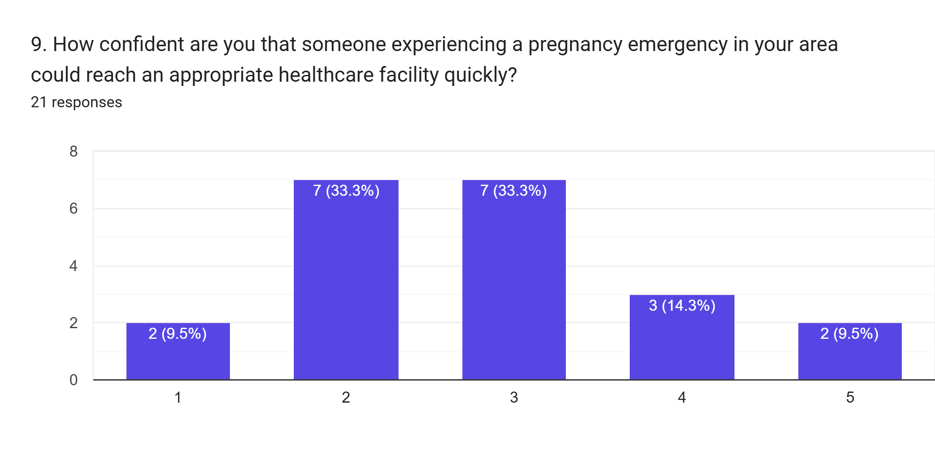
1.5 Learning Reflection (Discover)
During the discovery phase, I learned that maternal healthcare challenges involve more than simply providing medical information. Pregnant women and frontline healthcare workers may also need clear guidance on recognising potential danger signs, locating suitable healthcare facilities, and arranging timely referrals.
Initially, I understood the problem mainly as a lack of awareness about pregnancy complications. However, exploring the referral process helped me recognise that access to healthcare facility information and organised communication between people involved in maternal care are also important considerations.
This changed my approach from focusing only on awareness to proposing a more structured maternal healthcare support platform. MaatriRaksha is designed around the idea that recognising a possible complication should be accompanied by clear guidance to seek appropriate medical care.
The discovery process also highlighted the importance of simple language, accessible design, and reliable information. I learned that technology should support frontline healthcare workers rather than replace their judgement or professional medical care. The proposed platform will require further usability testing and review by qualified healthcare professionals before it can be considered suitable for real-world clinical use.

Chapter 2: Research: Understanding Users and Existing
Solutions

2.1 Research Methodology

The research for MaatriRaksha — “Recognize Early. Refer Early.” was conducted to understand the challenges associated with pregnancy danger signs, maternal healthcare awareness, and timely medical referrals. The research focused on identifying the needs of pregnant women and frontline healthcare workers, particularly ASHA and ANM workers.
A questionnaire was prepared and distributed using Google Forms to collect responses relevant to maternal healthcare awareness and referral challenges. The responses were intended to help identify areas where better information, accessible healthcare facility details, and structured referral support may be useful.
The collected responses can be analysed using charts and percentage calculations to identify common patterns. The research findings are intended to guide the design of the proposed website, including a maternal assessment checklist, risk alerts, healthcare facility information, and referral tracking.
Research tools: Google Forms, questionnaire responses, charts, and percentage analysis.
Limitations: The findings are limited to the respondents who participated in the questionnaire and may not represent the wider population. The research does not establish the clinical effectiveness of the proposed platform. Actual response counts and percentages should be included using the collected survey data.

2.2 Stakeholder Analysis

Stakeholder group | Who exactly | Need / concern | Method used
Primary users | Pregnant women and expectant mothers | Understand pregnancy danger signs and access timely medical assistance | Questionnaire and problem analysis
Secondary users | ASHA workers and ANM workers | Identify potential warning signs and support appropriate referrals | Stakeholder identification
Supporting stakeholders | Family members and caregivers | Recognise when medical attention may be needed and help pregnant women access care | Problem analysis
Healthcare providers | Primary healthcare centres, hospitals, and obstetric healthcare professionals | Receive referrals and provide appropriate medical assessment and treatment | Stakeholder identification
Influencers | Healthcare authorities and maternal health programme administrators | Promote reliable maternal health information and improve referral coordination | Review of publicly available information

2.3 Survey and Interview Findings
The Google Form questionnaire was used to explore maternal healthcare awareness and the challenges associated with pregnancy complications and referrals.
Research area | Purpose | Interpretation
Awareness of pregnancy danger signs | Understand whether respondents recognise potential warning signs | May identify a need for clearer maternal health information
Awareness of pregnancy complications | Explore understanding of possible pregnancy-related emergencies | Helps identify areas for awareness and education
Access to healthcare facilities | Understand difficulties in locating suitable medical services | Supports consideration of a healthcare facility search feature
Emergency referral awareness | Explore understanding of where and how to seek medical assistance | Helps identify the need for structured referral guidance
Frontline healthcare support | Understand the potential role of ASHA and ANM workers | Helps define the needs of the platform's supporting users

Key observations
The questionnaire was intended to identify gaps in maternal healthcare awareness and access to referral information. These findings can help determine which features should be prioritised in the proposed website.
One important consideration is that recognising a possible pregnancy complication is only one part of the process. Pregnant women and frontline healthcare workers may also need clear information about where to seek medical attention and how to arrange a referral.

2.4 Empathy Map and User Persona
Empathy map
The following is an illustrative persona based on the types of challenges explored in the project. It is not a direct quotation from an individual respondent.
Says | Thinks
“How do I know if this pregnancy symptom is dangerous?” | “I want to understand when I should seek medical help.”
“Where should I go for medical assistance?” | “Will I be able to reach the right healthcare facility in time?”

Does | Feels
Seeks advice from family members or local healthcare workers | Concerned when symptoms are unfamiliar
Tries to find information about nearby healthcare facilities | Uncertain about where to seek appropriate care

User persona
A pregnant woman seeking maternal healthcare guidance
Illustrative persona — to be refined using actual user research.
- Age: Not specified
- Location: Rural or semi-urban community
- Occupation: Not specified
The user wants to understand pregnancy danger signs and find appropriate medical assistance but may be uncertain about which symptoms require urgent attention and where to seek care.
Goals
- Understand pregnancy danger signs through simple information.
- Identify suitable healthcare facilities.
- Know how to seek medical assistance and referral support.
Frustrations
- Difficulty understanding unfamiliar medical information.
- Uncertainty about where to seek appropriate care.
- Limited access to clear and organised referral information.

2.5 Literature Review and Patent Search

No. | Source and type | What it does | Gap / limitation relevant to the project
1 | Ministry of Health and Family Welfare — maternal healthcare programmes | Provides policies and programmes related to maternal health in India. | Users may still require locally accessible guidance to navigate available services.
2 | ASHA workers and ANM workers — frontline healthcare services | Support community-level healthcare awareness and maternal health activities. | Their ability to provide support may depend on training, workload, and available resources.
3 | Primary healthcare centres and hospitals — healthcare services | Provide medical assessment, treatment, and referral services. | Users may need help identifying an appropriate facility and understanding where to seek care.
4 | Digital maternal health information platforms — digital solutions | Provide online maternal health information and resources. | Accessibility and usefulness may vary depending on language, connectivity, and user digital literacy.
5 | Emergency healthcare and referral services — healthcare support systems | Help patients access appropriate medical assistance when needed. | Users may not always know which service or facility to contact.

2.6 Benchmarking
This section compares existing maternal healthcare support approaches with the proposed MaatriRaksha platform.
Feature | Existing healthcare services | Community-based assistance | MaatriRaksha (proposed)
Maternal health information | Available through healthcare providers and information resources | Explained by frontline workers or family members | Organised maternal health information
Identification of danger signs | Based on appropriate clinical assessment and guidance | Depends on available knowledge and training | Assessment checklist to support recognition of potential warning signs
Healthcare facility information | Available through healthcare systems and directories | Shared through local knowledge and contacts | Healthcare facility search using verified information when available
Referral support | Managed through existing healthcare procedures | Supported by frontline workers and caregivers | Referral tracking and organised referral information
User accessibility | Varies by service and location | Depends on local support availability | Designed with a simple and accessible interface
Regional-language support | Varies by service | Can be provided through local-language communication | Planned regional-language support
Low-connectivity support | Varies by service | May be possible through direct interaction | Offline-friendly functionality is a proposed improvement
Clinical decision-making | Performed by qualified healthcare professionals | Depends on role and training | Does not replace professional medical assessment or emergency care
Benchmarking conclusion: MaatriRaksha is intended to complement existing maternal healthcare services rather than replace them. Its proposed difference is the combination of structured assessment support, healthcare facility information, and referral tracking in one accessible platform.

2.7 User Needs Document / Research Summary
Based on the problem analysis and the research objectives, the following user needs were identified:
- Simple information: Users need understandable information about pregnancy danger signs.
- Early recognition support: Frontline healthcare workers need structured tools to help identify potential warning signs.
- Healthcare facility discovery: Users need assistance finding suitable healthcare facilities.
- Referral guidance: Users need clear information about how to seek appropriate medical assistance.
- Referral tracking: Frontline workers need a way to organise and follow up on referrals.
- Accessible interface: Users need a simple interface that is easy to navigate.
- Regional-language support: Users should be able to understand important information in familiar languages.
- Human assistance: Users need access to qualified healthcare professionals when further assessment or assistance is required.
- Low-connectivity access: Users may benefit from features that work under limited internet connectivity.
- Reliable information: Users need accurate maternal health information reviewed by qualified professionals.
Research summary: The research phase focused on understanding maternal healthcare awareness, identifying barriers to timely referrals, and defining the needs of pregnant women and frontline healthcare workers. These findings inform the proposed MaatriRaksha platform, which aims to support recognition of potential pregnancy danger signs and improve access to referral information. Further user testing, verification of healthcare facility data, and clinical review are required before the platform can be considered for real-world use.

Chapter 3: Define: Problem Statement and Root Cause
Analysis

3.1 Problem Analysis (5 Whys)
Observed problem: Early warning signs of obstetric complications may be missed because frontline healthcare workers lack adequate assessment support and structured referral pathways.

Why | Question | Answer
1 | Why may pregnancy complications not be identified early? | Warning signs may not be recognised promptly or communicated effectively.
2 | Why might warning signs be missed? | Frontline healthcare workers may have limited access to structured assessment tools and supporting information.
3 | Why can this delay referrals? | Healthcare facility information and referral procedures may not be organised in an accessible, connected process.
4 | Why does this create difficulties for pregnant women? | They may be unsure where to seek medical attention or how to access appropriate healthcare services.
5 | Why does the problem persist? | There is a need for accessible assessment support, reliable facility information, and structured referral pathways.
Root cause identified: Limited assessment support for frontline healthcare workers and the absence of accessible, structured, and timely maternal healthcare referral pathways.

3.2 Fishbone Diagram / Problem Tree
The problem can be analysed through the following contributing factors:
Category | Contributing factors
People | Limited awareness of pregnancy danger signs and varying levels of healthcare knowledge.
Process | Lack of structured referral procedures and follow-up mechanisms.
Technology | Limited access to digital assessment tools and organised referral information.
Information | Difficulty accessing clear, reliable, and understandable maternal healthcare guidance.
Infrastructure | Uneven access to healthcare facilities and internet connectivity.
Coordination | Challenges in connecting frontline workers, pregnant women, and healthcare facilities.
Central problem: Delayed recognition of potential obstetric complications and difficulties arranging timely referrals.
Potential consequences: Delays in seeking appropriate medical care, difficulty locating suitable healthcare facilities, and gaps in referral coordination.

3.3 Engineering Constraints
Constraint | Description | How it will be addressed
Cost | The project must be affordable to develop and maintain. | Use open-source technologies and suitable free-tier services.
Time | Development and testing must fit within the academic project schedule. | Prioritise core features before optional improvements.
Connectivity | Some users may have weak or intermittent internet access. | Design lightweight pages and explore offline-friendly functionality.
Language | Users may prefer different regional languages. | Plan regional-language support, including Hindi and Marathi.
Data accuracy | Healthcare facility information may change. | Use reliable sources and verify facility details before displaying them.
Privacy and security | Maternal health information can be sensitive. | Minimise data collection and apply appropriate security measures.
Technical skills | The application must be manageable within available development resources. | Use established web technologies and a modular design.
Clinical safety | The platform must not provide misleading medical guidance. | Seek qualified healthcare review and make clear that the platform does not replace professional medical assessment.
Emergency response | Digital guidance must not delay urgent medical care. | Direct users with potential emergency warning signs to seek immediate professional medical assistance.

3.4 Final Problem Statement
“Early warning signs of obstetric complications are frequently missed in high-burden states due to under-equipped frontline workers and the absence of structured, real-time referral pathways.”

3.5 Objectives and Success Criteria
Objective | Success criterion
1. Support early recognition | The prototype provides a structured maternal assessment checklist to help identify potential warning signs.
2. Improve access to healthcare information | Users can access clear maternal health information through a simple interface.
3. Support healthcare facility discovery | Users can view available healthcare facility information from verified sources where available.
4. Organise referrals | The prototype provides a structured way to record and track referral information.
5. Improve accessibility | Core interfaces are designed to support mobile screens, readable text, and straightforward navigation.
6. Support regional-language access | Regional-language support is planned and can be evaluated during development.
7. Validate usability and safety | User testing, feedback collection, and qualified clinical review are conducted before considering real-world use.

Chapter 4: Connect: Engineering Knowledge Applied

Portfolio layer: Connect | NIRMAN Lab journey: Week 7

4.1 Subject Contribution Matrix
Semester subject | Concept / topic applied | How it helped my solution | Where used (section)
AIPS (Algorithms and Intelligent Problem Solving) | Algorithms, searching, filtering, and problem-solving techniques | Helps organise the logic for searching healthcare facilities and guiding users through the maternal healthcare referral process. | Healthcare Facility Finder and Referral Workflow
ASPD (Applied Statistics and Probability for Data Science) | Data collection, percentages, statistical analysis, and data interpretation | Helps analyse Google Form responses and identify patterns related to maternal healthcare awareness and referral challenges. | Survey Analysis and Research
DBMS (Database Management Systems) | Database design, CRUD operations, queries, and data validation | Supports the storage and retrieval of healthcare facility information and referral records, where implemented. | Database Design and Backend
LR (Logical Reasoning) | Logical analysis, assumptions, cause-and-effect reasoning, and the Five Whys technique | Helps identify the root causes of missed warning signs and difficulties in referral coordination. | Problem Analysis and User Workflow
JAVA | Object-oriented programming, classes, objects, methods, and conditional statements | Develops understanding of structured programming and logical decision-making that can be applied when designing application components. | Application Logic and Software Design

4.2 Concepts Applied: Worked Examples
Concept / method | Worked example or calculation | How it applies to the solution
ASPD: Percentage calculation | If 15 out of 23 respondents identify a particular concern, the percentage is \((15/23)\times100 = 65.22\%\). | Helps quantify survey findings and identify areas requiring attention. Use the calculation only if these numbers match the actual survey data.
AIPS: Searching algorithm | Compare the district selected by a user with the district recorded for each healthcare facility, then display matching records. | Helps users narrow down healthcare facility results.
DBMS: CRUD operations | Create a referral record, read its details, update its status, and retrieve relevant facility information. | Supports organised referral information management when these functions are implemented.
LR: Five Whys analysis | Missed warning signs → limited assessment support → difficulty identifying appropriate action → delays in referral coordination → need for structured assessment and referral support. | Helps identify underlying causes and connect them to the proposed solution.
JAVA: Conditional statements | if (riskLevel.equals("High")) { ... } | Demonstrates conditional logic. In MaatriRaksha, any clinical risk classification must be based on professionally reviewed criteria and must not replace medical assessment.

Worked Example 1: ASPD — Survey Analysis
Percentage calculation is useful for analysing questionnaire responses.
Given:
- Total respondents = 23
- Respondents reporting a particular concern = 15
Percentage=15/23*100=65.22%
Therefore, approximately 65.2% of respondents reported that concern. For MaatriRaksha, the same method can be used to analyse actual responses about pregnancy danger signs, maternal healthcare awareness, and referral challenges. The result must be reported according to the real survey data.

Worked Example 2: AIPS — Healthcare Facility Search
Suppose the healthcare facility dataset contains records from three districts. A user selects a district, and the search algorithm compares the selected district with the district field in each record. The matching records are then displayed.
This demonstrates how searching and filtering can make healthcare facility information easier to navigate. Facility details should be verified using reliable sources, and the displayed information should not imply that a facility offers a particular service unless that information has been confirmed.

Worked Example 3: DBMS — Referral Record Management
A referral record may contain a reference number, date, healthcare facility, and referral status.
The system can use database operations to:
- Create a new referral record.
- Read the referral details.
- Update the status when authorised information becomes available.
- Retrieve records for follow-up.
These operations illustrate how database concepts can support referral tracking. They should be described as implemented functionality only if the corresponding database and backend operations have actually been developed.

Worked Example 4: LR — Root Cause Analysis
The Five Whys technique helps investigate why pregnancy complications may not be recognised or referred promptly.
- Problem: Pregnancy danger signs may be missed.
- Why? Frontline workers may lack structured assessment support.
- Why? Relevant information and assessment resources may not be readily accessible.
- Why? Healthcare information and referral processes may be fragmented.
- Why? A structured, accessible referral pathway may be absent.
This analysis supports the design direction of MaatriRaksha: combining assessment support, healthcare facility information, and referral organisation in one proposed platform.

Worked Example 5: JAVA — Conditional Logic
A simple conditional statement in Java can demonstrate how an application chooses an action based on a value.
if (requestCategory.equals("Facility Search")) {
System.out.println("Show healthcare facility options.");
} else if (requestCategory.equals("Referral Support")) {
System.out.println("Show referral guidance.");
}
This example demonstrates basic conditional logic that can help organise different user workflows. It is an illustrative Java example, not proof that the website itself is implemented in Java.
Connection summary: The semester subjects contribute to different parts of MaatriRaksha. ASPD supports survey analysis, AIPS supports search and filtering, DBMS supports information management, LR supports problem analysis, and JAVA builds programming and logical-thinking skills. Together, these subjects provide an engineering foundation for developing and evaluating the proposed maternal healthcare support platform.

Chapter 5: Ideation and Concept Selection

Portfolio layer: Ideate | NIRMAN Lab journey: Weeks 8–9
5.1 Techniques Used
The following techniques were used to explore possible solutions for the MaatriRaksha project:
- Brainstorming: Generated ideas to improve pregnancy danger-sign awareness and maternal healthcare referrals.
- Design Thinking: Focused on understanding the needs of pregnant women and frontline healthcare workers before selecting a solution.
- SCAMPER: Explored ways to improve existing maternal health information and referral processes.
- Mind Mapping: Connected the main problem with its causes, stakeholders, and potential solutions.
- Concept Evaluation: Compared shortlisted ideas based on feasibility, impact, cost, innovation, and sustainability.

5.2 Idea Bank (20 Ideas)
No. | Idea | No. | Idea
1 | Maternal healthcare information website | 11 | Maternal health FAQ chatbot
2 | MaatriRaksha maternal support platform | 12 | Healthcare facility search system
3 | SMS-based pregnancy warning information | 13 | Maternal health information checklist
4 | Voice-based maternal healthcare guidance | 14 | Pregnancy danger-sign awareness guide
5 | Regional-language maternal health application | 15 | Referral request tracking system
6 | Interactive pregnancy health FAQ portal | 16 | ASHA and ANM support directory
7 | Nearby healthcare facility directory | 17 | Step-by-step referral guidance
8 | Community maternal health awareness campaign | 18 | Low-connectivity maternal health portal
9 | Printed pregnancy danger-sign booklet | 19 | Audio-based maternal health instructions
10 | Educational videos about pregnancy complications | 20 | Integrated maternal assessment and referral platform

5.3 Concept Sketches
The concept sketches illustrate the proposed design direction of MaatriRaksha.

Sketch 1: Website Homepage
The homepage introduces MaatriRaksha and provides clear options to access maternal health information, complete an assessment checklist, and find healthcare facilities.

Sketch 2: Healthcare Facility Finder
The interface allows users to search for healthcare facilities and view available location and service information.
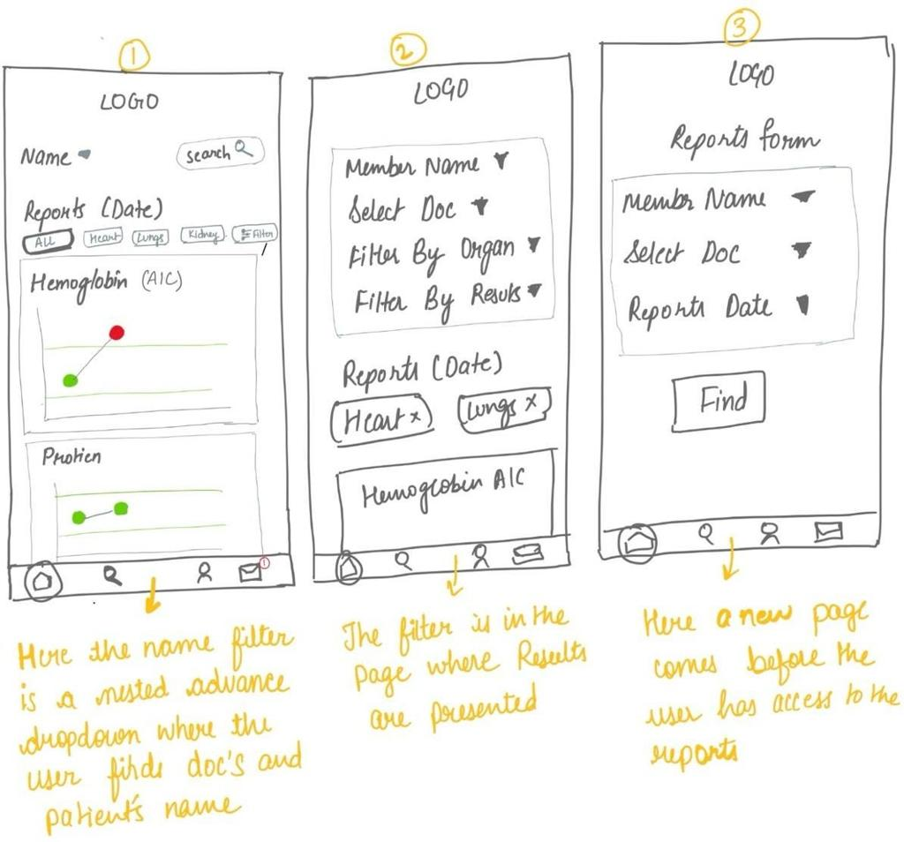
Sketch 3: Referral Tracking
The screen organises referral details and status information to help frontline workers follow up on referrals.
These are illustrative design references. Replace them with your own actual sketches or screenshots if your report requires evidence of your design process.

5.4 Evaluation Matrix
Each concept is scored from 1 to 5, where 5 represents the most favourable score. For cost, a higher score indicates lower implementation cost.
- Concept A: Maternal health information website
- Concept B: SMS and voice-based maternal health service
- Concept C: MaatriRaksha assessment and referral platform

Criteria | Concept A | Concept B | Concept C
Feasibility | 5 | 3 | 4
Impact on users | 3 | 4 | 5
Cost | 5 | 3 | 4
Innovation | 2 | 4 | 5
Sustainability | 4 | 3 | 4
Total / 25 | 19 | 17 | 22
These are preliminary design judgements, not measured evaluation results. The scores should be reviewed against the project's actual development resources and constraints.

5.5 Rejected Ideas and Reasons
Idea | Reason for not selecting it as the main solution
General maternal health information website | Provides information but may not organise assessment support and referral tracking in one workflow.
SMS-only service | Useful for basic phones but limited for displaying detailed facility information and interactive assessment guidance.
Voice-only service | May improve accessibility but could be difficult to implement comprehensively within the project timeline.
Printed maternal health booklet | Affordable and usable offline, but information may become outdated and it cannot track referrals.
Standalone FAQ chatbot | Can answer common questions but may not provide an integrated workflow for assessment, facility discovery, and referral tracking.

5.6 Selected Concept and Justification
The selected concept is MaatriRaksha — “Recognize Early. Refer Early.”, a proposed maternal healthcare support platform designed to assist pregnant women and frontline healthcare workers in accessing maternal health information and organising referrals.
The concept was selected because it addresses several connected challenges: recognising pregnancy danger signs, accessing reliable healthcare facility information, and arranging appropriate referrals. Rather than providing only general awareness content, the platform aims to bring these activities together through a straightforward interface.
The proposed website includes a maternal assessment checklist, risk alerts, healthcare facility information, and referral tracking. Regional-language support and offline-friendly functionality are additional design goals.
Compared with a general information website or a single-channel SMS service, MaatriRaksha aims to provide a more connected maternal healthcare support workflow. It is intended to complement existing healthcare services, not replace qualified medical professionals. Any risk alerts must be reviewed by qualified healthcare professionals, and users with possible emergency warning signs should seek immediate medical attention.
Chapter 6: Design

6.1 Design Overview
MaatriRaksha — “Recognize Early. Refer Early.” is designed as a maternal healthcare support website. It aims to help pregnant women and frontline healthcare workers access maternal health information, identify potential pregnancy danger signs, find healthcare facilities, and organise referrals.
The proposed system follows a client-server architecture. The frontend provides the user interface, the backend processes requests, and the database stores application information such as healthcare facility records and referral details, depending on the implemented functionality.
The primary workflow is:
- The user accesses maternal healthcare information.
- The user completes a maternal assessment checklist, where available.
- The platform presents relevant guidance and risk alerts based on professionally reviewed criteria.
- The user accesses healthcare facility information.
- The referral workflow helps organise and track referral details, where implemented.
The platform is intended to support healthcare navigation, not replace professional medical assessment. Potential emergency warning signs require prompt medical attention.

6.2 Design Iterations
Iteration | Design / drawing reference | What changed and why | Result
Iteration 1 | Initial maternal healthcare website concept | Started with a general maternal health information layout. | Identified the need for accessible maternal health information.
Iteration 2 | Maternal assessment and healthcare facility workflow | Added assessment support and facility discovery to address the need for practical guidance. | Established a more task-oriented design direction.
Iteration 3 | MaatriRaksha website design | Organised the proposed features around maternal assessment, healthcare facility information, and referral support. | Established a clearer design direction for the proposed platform.

These iterations describe the design direction. Replace or refine them using your actual sketches, design versions, and screenshots if available.

6.3 Drawings and Models
The main design models for MaatriRaksha are:
- System architecture diagram: Illustrates communication between the frontend, backend, and database, according to the implemented architecture.
- User workflow diagram: Shows how users access maternal health information, complete the assessment checklist, locate facilities, and proceed towards referral support.
- UI wireframes: Illustrate the proposed homepage, maternal assessment checklist, healthcare facility search interface, and referral tracking interface.
- Database model: Defines the fields and relationships required for healthcare facility information and referral records, depending on the implemented database.

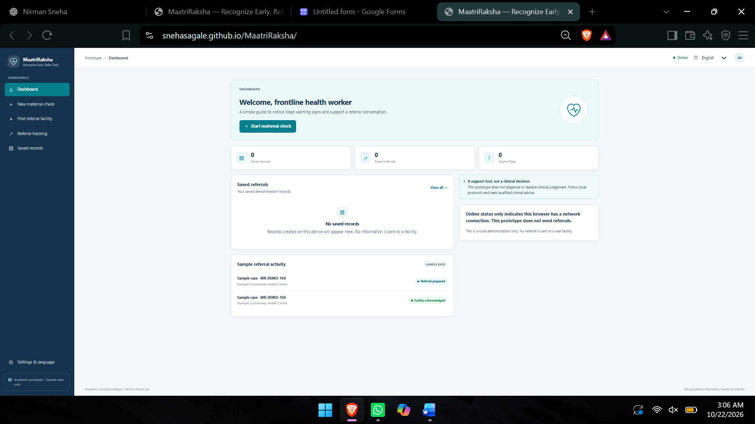

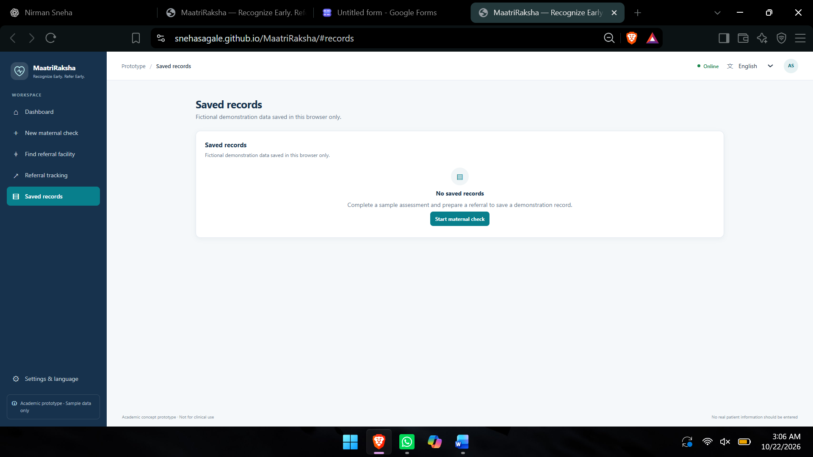

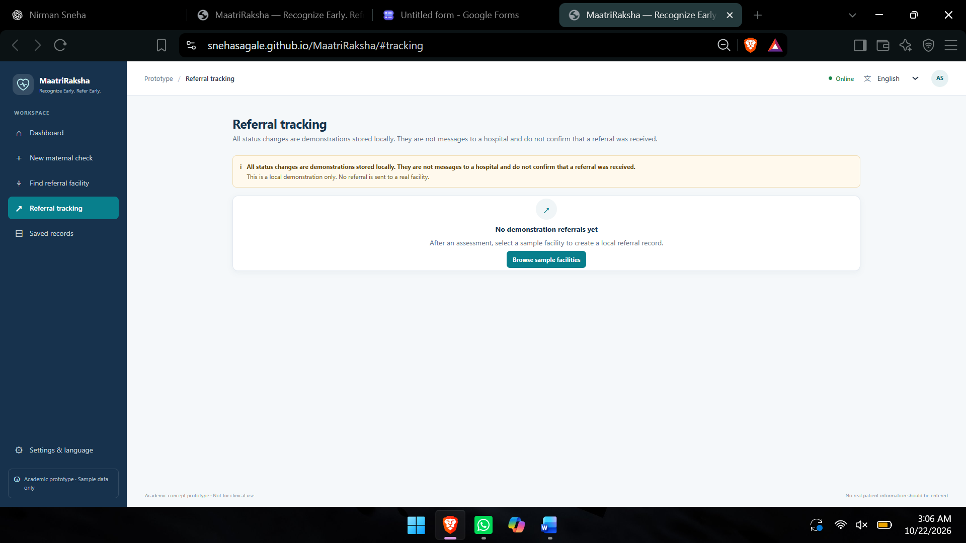

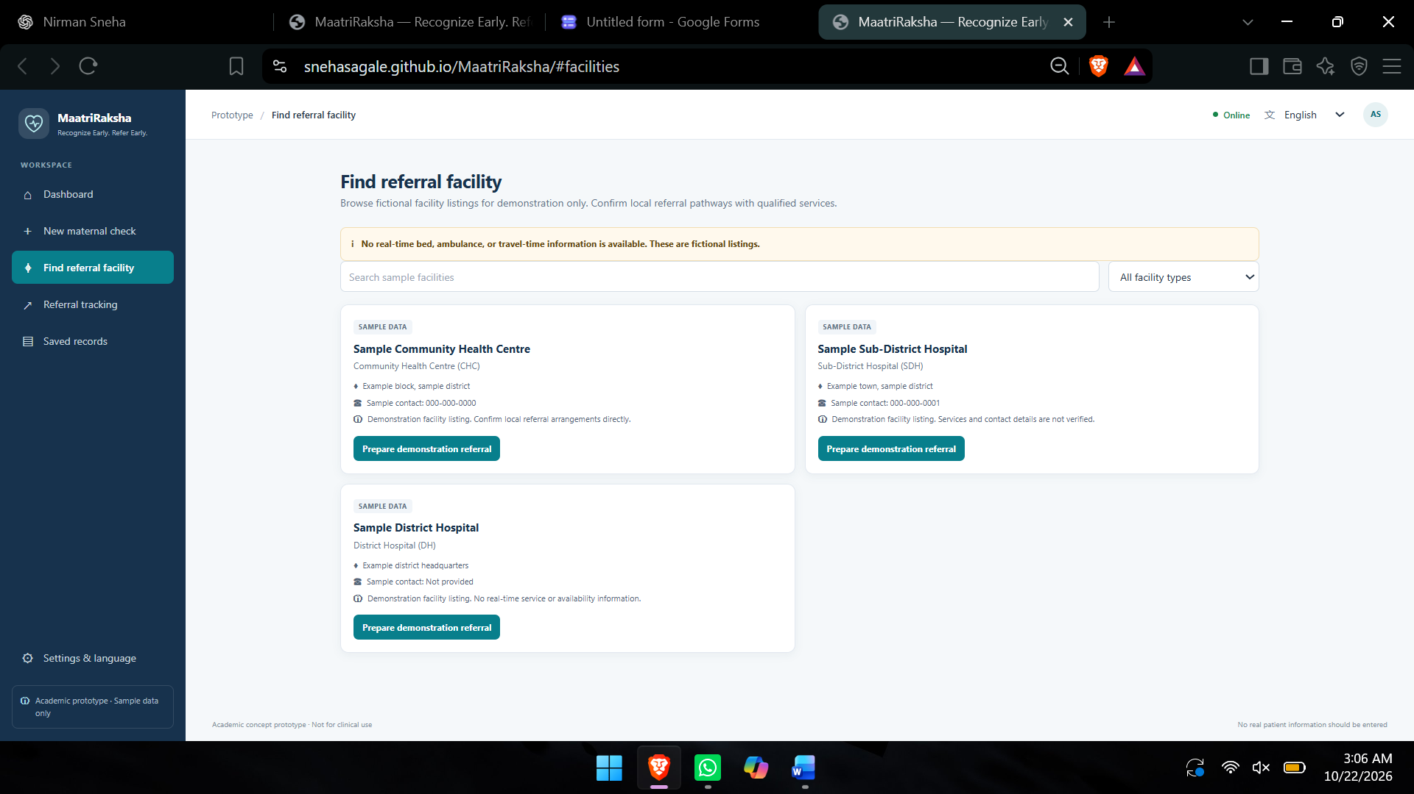

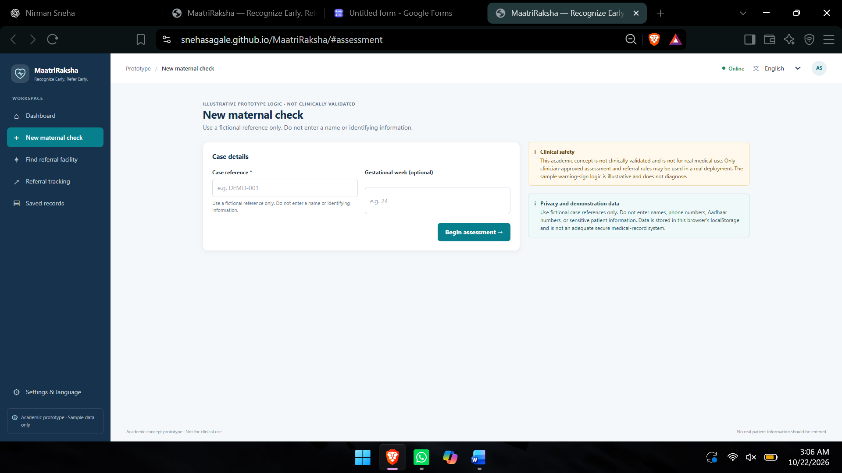

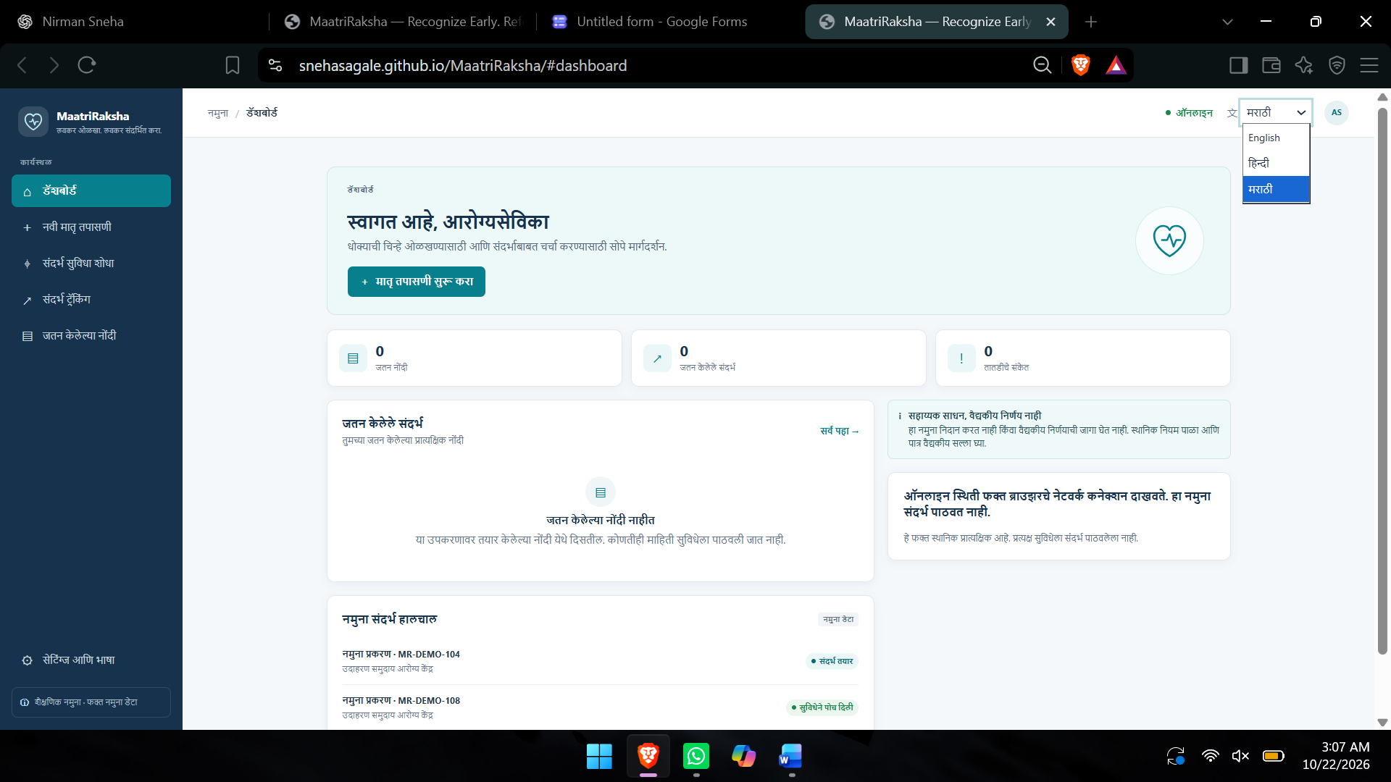

6.4 Selection of Materials, Components and Tools
Component / tool | Reason for selection
HTML | Provides the structure of the website pages.
Tailwind CSS | Supports consistent styling and responsive layouts.
JavaScript | Enables interactive interface elements and client-side logic.
Node.js and Express | Provide a framework for backend APIs and request processing.
MongoDB Atlas | Can provide cloud-based persistent storage for application records.
Git and GitHub | Support version control and tracking changes during development.
Browser developer tools | Help test responsive layouts, identify errors, and debug the website.
Include only the technologies you actually used or selected for your project. Proposed tools should not be described as implemented unless you have used them.

6.5 Bill of Materials and Cost
Item | Qty | Unit cost | Total
HTML, Tailwind CSS and JavaScript | 1 set | ₹0 | ₹0
Node.js and Express | 1 setup | ₹0 | ₹0
MongoDB Atlas | 1 setup | ₹0* | ₹0*
Git and GitHub | 1 setup | ₹0* | ₹0*
Computer and internet access | Existing resources | Not calculated | Not calculated
Estimated software cost |  |  | ₹0*
₹0 assumes the use of available free software and free-tier services within their usage limits. Hosting, internet access, and any paid services may involve additional costs.

Chapter 7: Build: Prototype Development

7.1 Implementation Process
The MaatriRaksha website was planned as a maternal healthcare support platform to help pregnant women and frontline healthcare workers access maternal health information, identify potential pregnancy danger signs, and organise healthcare referrals. The development process involves the following steps:
1. Requirement identification: I identified the main project requirements, including maternal health awareness, pregnancy danger-sign assessment, healthcare facility information, and referral support.
2. Interface design: I planned the website layout to keep navigation simple and make the main features easy to find. The design focuses on readability, accessibility, and responsiveness across mobile and desktop devices.
3. Frontend development: I selected HTML, Tailwind CSS, and JavaScript to structure the website, style the interface, and support interactive elements such as forms, buttons, and navigation.
4. Backend development: Node.js and Express were selected as the proposed backend technologies for processing requests, validating submitted information, and connecting the frontend to application data.
5. Database integration: MongoDB Atlas was selected as the proposed database for storing application information, such as healthcare facility records and referral details, depending on the implemented data model.
6. Testing and refinement: The proposed workflows require testing for navigation, form validation, responsiveness, and usability. Further user testing and clinical review are necessary before real-world use.

7.2 Prototype Photographs / Screenshots
Figure 7.1: MaatriRaksha Website Homepage
The homepage introduces the platform and provides navigation to its maternal healthcare support features.

Figure 7.2: Maternal Assessment Checklist Interface
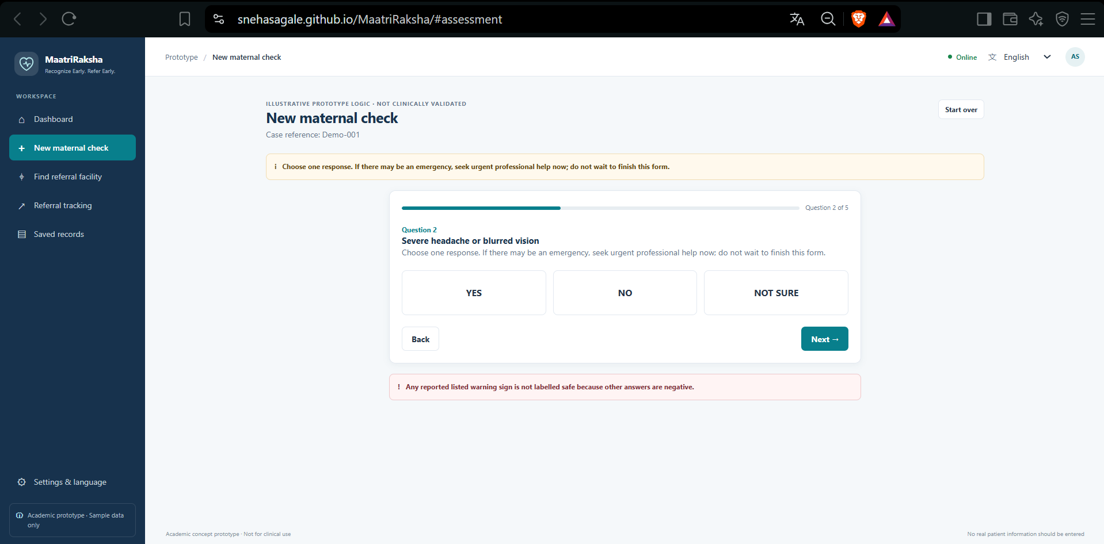
The proposed interface is intended to help users review pregnancy-related warning signs and access appropriate guidance.

Figure 7.3: Healthcare Facility Search Interface
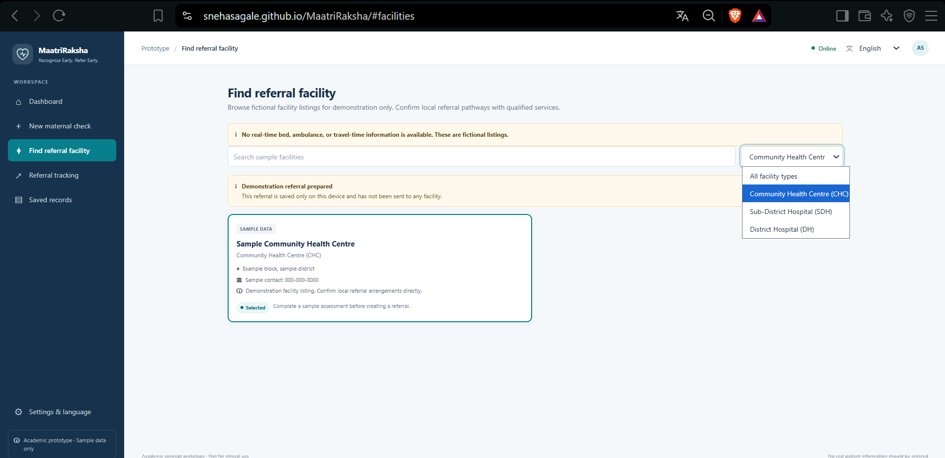
The facility finder is intended to help users locate relevant healthcare facility information.

Figure 7.4: Referral Tracking Interface
This interface is intended to organise referral details and support follow-up where the corresponding functionality is available.

7.3 Problems Faced and Solutions
Problem faced | Solution / approach
Making maternal healthcare information easy to understand | Organised the proposed interface around clear actions and simple instructions.
Designing a layout for different screen sizes | Used responsive design principles and planned mobile-friendly controls.
Organising the assessment and referral workflow | Divided the proposed process into understandable steps.
Maintaining accurate healthcare facility information | Identified the need to use reliable sources and verify facility details.
Protecting sensitive maternal health information | Considered data minimisation, input validation, and secure handling of database credentials.
Avoiding misleading medical guidance | Positioned the platform as a support tool rather than a replacement for professional medical assessment.
Supporting timely medical assistance | Included referral support in the design and recognised that emergency symptoms require immediate medical attention.

7.4 Links to Code, Design Files and Videos
Resource | Link
Source code repository | Add your MaatriRaksha GitHub repository link, if available.
Live website | Add your MaatriRaksha website link, if deployed.
Design files or wireframes | Add your design file link, if available.
Prototype demonstration video | Add your demonstration video link, if available.

Chapter 8: Validate: Testing and Results

Portfolio layer: Validate | NIRMAN Lab journey: Weeks 12–13

8.1 Test Plan
The purpose of testing is to evaluate whether MaatriRaksha can provide accessible maternal healthcare information and support users in navigating the proposed assessment, healthcare facility search, and referral workflows. Testing should focus on usability, functionality, accessibility, and information reliability.
Test area | What will be tested | Method | Success criteria
Navigation | Accessing the main website sections | Task-based testing | Users can find the required section.
Maternal assessment checklist | Viewing and completing the assessment | Functional testing | Inputs are handled correctly and instructions are clear.
Risk alerts | Displaying guidance based on assessment responses | Functional and safety review | Guidance follows professionally reviewed criteria and does not replace medical assessment.
Healthcare facility search | Searching and filtering facility records | Functional testing | Relevant available records are displayed correctly.
Referral tracking | Retrieving and viewing referral information | Integration testing | Valid records can be retrieved with appropriate access controls, if implemented.
Responsive design | Mobile and desktop layouts | Device and browser testing | Content remains readable and controls are usable without horizontal scrolling.
Accessibility | Text readability, keyboard navigation, and contrast | Accessibility review | Core tasks can be completed using accessible controls.

8.2 User Testing and Feedback
The following table is a template for recording actual user-testing feedback. Tester names, observations, and actions should be included only when supported by your testing records.
# | Tester (role / age) | Feedback / observation | Action taken
1 | Participant 1 — role/age to be recorded | Record feedback about the homepage and navigation. | Record the actual change made, if any.
2 | Participant 2 — role/age to be recorded | Record feedback about the maternal assessment checklist. | Record the actual change made, if any.
3 | Participant 3 — role/age to be recorded | Record feedback about healthcare facility information. | Record the actual change made, if any.
4 | Participant 4 — role/age to be recorded | Record feedback about readability and language accessibility. | Record the actual change made, if any.
5 | Participant 5 — role/age to be recorded | Record feedback about referral tracking and guidance. | Record the actual change made, if any.

8.3 Results and Performance
The Google Form survey was conducted to understand maternal healthcare awareness and referral-related challenges. The results below should be completed using the actual questionnaire responses.
Parameter | Result | Interpretation
Awareness of pregnancy danger signs | To be filled using actual survey data | Helps identify awareness gaps.
Understanding of pregnancy complications | To be filled using actual survey data | Helps determine the need for clearer maternal health information.
Access to healthcare facilities | To be filled using actual survey data | Helps identify facility-navigation challenges.
Awareness of referral services | To be filled using actual survey data | Helps determine the need for structured referral guidance.
User feedback on the prototype | To be recorded after actual testing | Helps identify usability improvements.

Interpretation: The questionnaire and prototype testing serve different purposes. The questionnaire explores the problem and user needs, while prototype testing evaluates the usability and functionality of the proposed solution. Survey results should not be presented as proof that the website is effective.

8.4 Failure Analysis
Potential failure points to investigate during testing include:
Potential failure | Possible cause | Lesson / corrective approach
Users cannot find maternal health guidance | Unclear navigation or unfamiliar wording | Make the guidance entry point more visible.
Assessment inputs are not processed correctly | Invalid inputs or incomplete form validation | Validate inputs and provide clear error messages.
Healthcare facility search returns no results | Incorrect filters or incomplete data | Improve search logic and empty-state messages.
Referral tracking fails | Invalid reference or backend/database error | Validate requests and display clear error messages.
Website is difficult to use on mobile | Layout or touch-target issues | Test different screen sizes and refine responsive styling.
Users misunderstand risk alerts | Unclear wording or insufficient safety guidance | Use professionally reviewed language and direct users to appropriate medical care.
Sensitive information is exposed | Inadequate access controls or data handling | Minimise collected data and apply appropriate security controls.

8.5 Improvements and Refinement
The following improvements are proposed for evaluation during prototype testing.
Feedback / issue to investigate | Proposed change | Expected improvement
Homepage navigation may be unclear | Organise the main actions into easily identifiable sections. | Users can identify important features more easily.
Maternal healthcare guidance may be difficult to understand | Use simple language and improve field labels. | The workflow becomes easier to understand.
Healthcare facility information may be difficult to navigate | Improve search filters and facility result presentation. | Users can locate relevant facility information more easily.
Referral tracking may be confusing | Provide clear status descriptions and explain the purpose of referral tracking. | Users better understand referral information.
Regional-language access may be limited | Explore Hindi and Marathi interface options. | More users may be able to understand the information.
Clinical guidance requires verification | Arrange review by qualified healthcare professionals. | Improves the reliability and safety of the information before real-world use.

Validation summary: MaatriRaksha is intended to support maternal healthcare awareness and referral organisation. Actual usability findings, completed test results, and observed improvements should be documented after testing the prototype with users. Clinical review is also necessary before the platform is considered for real-world maternal healthcare use.

Chapter 9: Impact: SDG, Ethics, Safety and Cost

9.1 Beneficiaries
The primary beneficiaries of MaatriRaksha — “Recognize Early. Refer Early.” are pregnant women who need accessible maternal healthcare information and timely referral support. Secondary beneficiaries include ASHA workers, ANM workers, family members, caregivers, primary healthcare centres, and hospitals involved in maternal healthcare.
The project focuses on supporting the recognition of potential pregnancy danger signs, improving access to healthcare facility information, and organising referral-related information. Frontline healthcare workers may benefit from structured assessment support, while pregnant women and their families may benefit from clearer guidance on seeking appropriate medical care.
The platform could benefit a wider population if implemented and validated successfully, particularly people who face barriers related to healthcare awareness, digital literacy, language, or access to reliable information.

9.2 SDG Impact
SDG | Target | Contribution
SDG 3: Good Health and Well-being | Target 3.1: Reduce maternal mortality | Supports the broader goal of improving maternal health through earlier recognition of potential danger signs and timely referral support.
SDG 3: Good Health and Well-being | Target 3.8: Universal health coverage | Aims to improve access to maternal healthcare information and facility navigation.
SDG 10: Reduced Inequalities | Target 10.2: Promote inclusion for all | Aims to reduce information and digital-access barriers for pregnant women and frontline healthcare workers.
Potential impact indicators:
- Number of users accessing maternal health information.
- Number of assessment checklists completed.
- Number of healthcare facility searches performed.
- Number of referrals recorded or tracked.
- User task-completion rate and satisfaction.
- Feedback from ASHA and ANM workers.
These indicators would need to be measured during actual implementation and evaluation.

9.3 Cost, Environmental and Social Impact
MaatriRaksha can be developed using open-source web technologies and suitable free-tier services, reducing initial software expenses. Actual costs may increase depending on hosting requirements, database storage, domain registration, and external service integrations.
Environmentally, the digital platform may reduce reliance on printed maternal healthcare information by providing guidance electronically. However, its actual environmental impact would depend on user adoption and whether it reduces the use of printed materials or unnecessary travel.
Socially, the project aims to improve access to maternal healthcare information, support frontline healthcare workers, and help pregnant women identify appropriate next steps when seeking medical assistance. It may also support better organisation of referral information. The platform cannot guarantee improved clinical outcomes and requires further testing before real-world use.

9.4 Ethics and Safety
The project follows these ethical and safety principles:
- Privacy: Collect only the information necessary for the intended functionality and protect sensitive maternal health data.
- Consent: Explain the purpose of data collection before users submit information.
- Accuracy: Use reliable maternal health guidance and verified healthcare facility information.
- Transparency: Clearly identify the website as an academic project rather than an official healthcare service.
- Fairness: Design the interface for users with different levels of digital literacy and language preferences.
- Clinical safety: Do not present the platform as a diagnostic tool or a replacement for qualified healthcare professionals.
- Emergency response: Encourage users experiencing potential emergency warning signs to seek immediate professional medical attention.
- Security: Protect database credentials, validate inputs, and restrict access to sensitive referral information.
- Clinical review: Obtain qualified healthcare professional review of assessment criteria and risk-alert wording before real-world use.

9.5 Scalability and Sustainability
MaatriRaksha could be expanded to additional districts and states by incorporating verified healthcare facility information, additional regional languages, and locally relevant maternal health guidance. Future versions could introduce voice assistance, SMS-based support, improved offline functionality, and authorised integrations with healthcare systems.
The platform could be maintained through collaboration among developers, healthcare professionals, frontline healthcare workers, and relevant healthcare organisations. Regular updates, security reviews, user feedback, and verification of healthcare facility information would be necessary for long-term reliability.
The project's sustainability depends on maintaining accurate information, controlling operating costs, protecting user privacy, and ensuring that the platform complements existing maternal healthcare services. Continued usability testing and clinical review would also be essential before the system could be considered for broader deployment.

Chapter 10: Reflection, Conclusion and Future Work

10.1 Conclusion
The project MaatriRaksha — “Recognize Early. Refer Early.” was developed under the theme “Arogya Pranali: Intelligent Health Systems for Bharat” to address challenges associated with recognising pregnancy danger signs and arranging timely maternal healthcare referrals.
The research focused on understanding the needs of pregnant women and frontline healthcare workers, particularly ASHA and ANM workers. Based on the identified problem, I proposed a maternal healthcare support platform that aims to provide a maternal assessment checklist, risk alerts, healthcare facility information, and referral tracking.
The project applies engineering concepts from AIPS, ASPD, DBMS, Logical Reasoning, and Java to problem analysis, survey interpretation, searching, information management, and software design.
The project established a clear problem statement and a proposed digital solution. However, the effectiveness of MaatriRaksha in improving maternal healthcare access has not yet been established and requires further functional testing, real-user validation, and review by qualified healthcare professionals.

10.2 Reflection
While working on this project, I learned that maternal healthcare challenges involve more than simply providing information about pregnancy. Pregnant women and frontline healthcare workers may also need support in recognising potential warning signs, locating suitable healthcare facilities, and organising timely referrals.
Initially, I focused on the importance of maternal health awareness. However, the research helped me understand that accessible information must be accompanied by practical guidance on seeking appropriate medical care. This became the central idea behind MaatriRaksha.
I also understood the importance of designing a simple interface for users with different levels of digital literacy and language preferences. Applying statistical analysis helped me understand how questionnaire responses can inform design decisions, while logical reasoning helped me analyse the underlying causes of the problem. Database management and programming concepts helped me understand how information and referral workflows could be organised.
One important lesson was that a digital healthcare platform must prioritise accuracy, privacy, accessibility, and safety. A well-designed interface alone cannot guarantee reliable healthcare support. Clinical guidance must be reviewed by qualified professionals, and healthcare facility information must be verified.
This project changed my approach from focusing only on website development to considering how engineering can address a genuine community problem. It also helped me recognise the importance of gathering user feedback and testing a proposed solution rather than assuming that the design will work as intended.

10.3 Limitations
The project has the following limitations:
- The questionnaire findings may not represent the wider population.
- The research does not establish the clinical effectiveness of the proposed platform.
- The website's usability and effectiveness require further testing with actual users.
- Healthcare facility information may become outdated unless it is regularly verified.
- Regional-language support and accessibility may require further improvements.
- Reliable offline functionality and SMS or voice-based assistance may require additional development and infrastructure.
- Clinical assessment criteria and risk alerts require review by qualified healthcare professionals.
- Integration with existing healthcare systems may require appropriate permissions and technical arrangements.

10.4 Future Work
Future development will focus on improving the reliability, accessibility, and usefulness of MaatriRaksha.
- User testing: Conduct usability studies with pregnant women and frontline healthcare workers to identify difficulties and improve the interface.
- Regional-language support: Expand language options and improve instructions for users with different language preferences.
- Verified healthcare facility information: Use reliable, regularly updated sources for healthcare facility locations and available services.
- Clinical review: Work with qualified healthcare professionals to review the assessment checklist, risk alerts, and maternal health guidance.
- Voice and low-connectivity features: Explore voice-based guidance, SMS support, and offline-friendly functionality.
- Security and privacy: Strengthen input validation, access controls, and protection of sensitive maternal health information.
- Referral coordination: Explore ways to improve communication and follow-up between frontline workers and healthcare facilities.
- Performance evaluation: Measure task-completion rates, time taken to find facility information, user satisfaction, and errors encountered during testing.

References
References
[1] Ministry of Health and Family Welfare, Government of India, “Maternal Health.” [Online]. Available: https://mohfw.gov.in/
[2] National Health Mission, Government of India, “Maternal Health Programme.” [Online]. Available: https://nhm.gov.in/
[3] World Health Organization, “Maternal Health.” [Online]. Available: https://www.who.int/health-topics/maternal-health
[4] World Health Organization, “WHO Recommendations on Antenatal Care for a Positive Pregnancy Experience.” [Online]. Available: https://www.who.int/publications/i/item/9789241549912
[5] United Nations, “Goal 3: Ensure Healthy Lives and Promote Well-being for All at All Ages,” Sustainable Development Goals. [Online]. Available: https://sdgs.un.org/goals/goal3
[6] United Nations, “Goal 10: Reduce Inequality Within and Among Countries,” Sustainable Development Goals. [Online]. Available: https://sdgs.un.org/goals/goal10
[7] Google, “Google Forms: Online Form Builder.” [Online]. Available: https://www.google.com/forms/about/
[8] Tailwind Labs, “Tailwind CSS Documentation.” [Online]. Available: https://tailwindcss.com/docs
[9] OpenJS Foundation, “Node.js Documentation.” [Online]. Available: https://nodejs.org/docs/
[10] MongoDB, “MongoDB Atlas Documentation.” [Online]. Available: https://www.mongodb.com/docs/atlas/
[11] National Health Mission, Government of India, “Guidelines and Programmes for Maternal Healthcare.” [Online]. Available: https://nhm.gov.in/
[12] Maternal Healthcare Awareness and Referral Survey, conducted by Sneha Sagale, questionnaire responses collected through Google Forms, 2026. Primary research.
*Note: Include reference [12] only with your actual survey link. Add any other sources you consulted directly while preparing the project.

Appendices

- Appendix A: Survey questionnaire and response data
https://docs.google.com/forms/d/e/1FAIpQLSfgT36BMBgFX9gADUym99HzRqtvaF3-6fD4UO493qJ2ET8hhw/viewform?usp=dialog

- Appendix B: Interview transcripts / notes and consent forms

- Appendix C: Additional photographs and field notes

- Appendix D: Sketches, brainstorming sheets and design drawings

- Appendix E: Code, CAD files, simulation files and links
https://snehasagale.github.io/MaatriRaksha/

- AppendixF F: Copy of Nirman Lab Project Diary & Logbook (signed pages)

- Appendix G: Poster / presentation and Expo feedback

